James Fort Project

Background:
America’s origins really begin in 1607 with the establishment of Jamestown, America’s first permanent English settlement in the New World. Chosen for its location, Jamestown’s geography nearly led to its demise. Surrounded by swampland (full of malaria carrying mosquitoes) and brackish, sometimes poisonous water, the colonists could not have chosen a worse location. Harsh weather conditions combined with often hostile relations with the local Powhattan tribe, made Jamestown’s survival a true testament to the enduring human spirit.
Upon arrival, one of the colonists’ first tasks was to create a protective fort, later named James Fort in honor of the sitting king, King James. Living in tents until the forts completion, the colonists then began to build their village, Jamestown.

Purpose:
For our first project you will work in pairs to create a model of the James Fort. The purpose of this project is for students to better understand the many challenges experienced at Jamestown and to closer examine America in its infant stage. Students should walk away from this project having gained a hands-on experience into America’s first settlement.

Expectations:
I’m looking for four specific criteria in regards to your James Fort model.
- Geography – Students’ projects need to accurately portray Jamestown’s geography. The inclusion of specific geographic features such as a swamp (the Pitch and Tar Swamp) and a river (the James River) is imperative to understanding Jamestown settlement. These will also be posted on the class website!

Check out the following link for specifics on Jamestown’s geography:

http://www.lib.utexas.edu/maps/national_parks/coloni_jame94.jpg
http://www.virtualjamestown.org/map5.html

- Fortifications– Your protective fort should be historically accurate. Check out the following links for images of the protective fortifications:

http://www.atlantic-gmbh.com/jamestown_image002.jpg
http://www.gatter.net/Html/Genealogy/America/Visu/Jamestown-Fort.jpg
http://1.bp.blogspot.com/_xs9T-jlzwhA/TIIuvFqoH1I/AAAAAAAAm1A/zLeEytlvSY8/s320/Jamestowncolony.jpg
http://www.virtualjamestown.org/map5.html

- Buildings – Within the walls of your fort should be at least three standing structures. Choose which buildings you want to include. Possible buildings within the fort could be a church, living quarters, the governor’s residence, a storehouse, etc.

http://www.atlantic-gmbh.com/jamestown_image002.jpg

- Legend or Key – Every good model has a legend or key. This legend should identify all key areas of interest on your project, including geographic features, names of buildings, etc.

Example of a James Fort model
We used basic supplies such as poster-board, tooth picks, glue, pieces of a shrub from our yard, pine straw, cardboard, and of course our imaginations. Materials should be brought in from home in order to make the detailed fort. Cardboard will be provided for the base of the project.
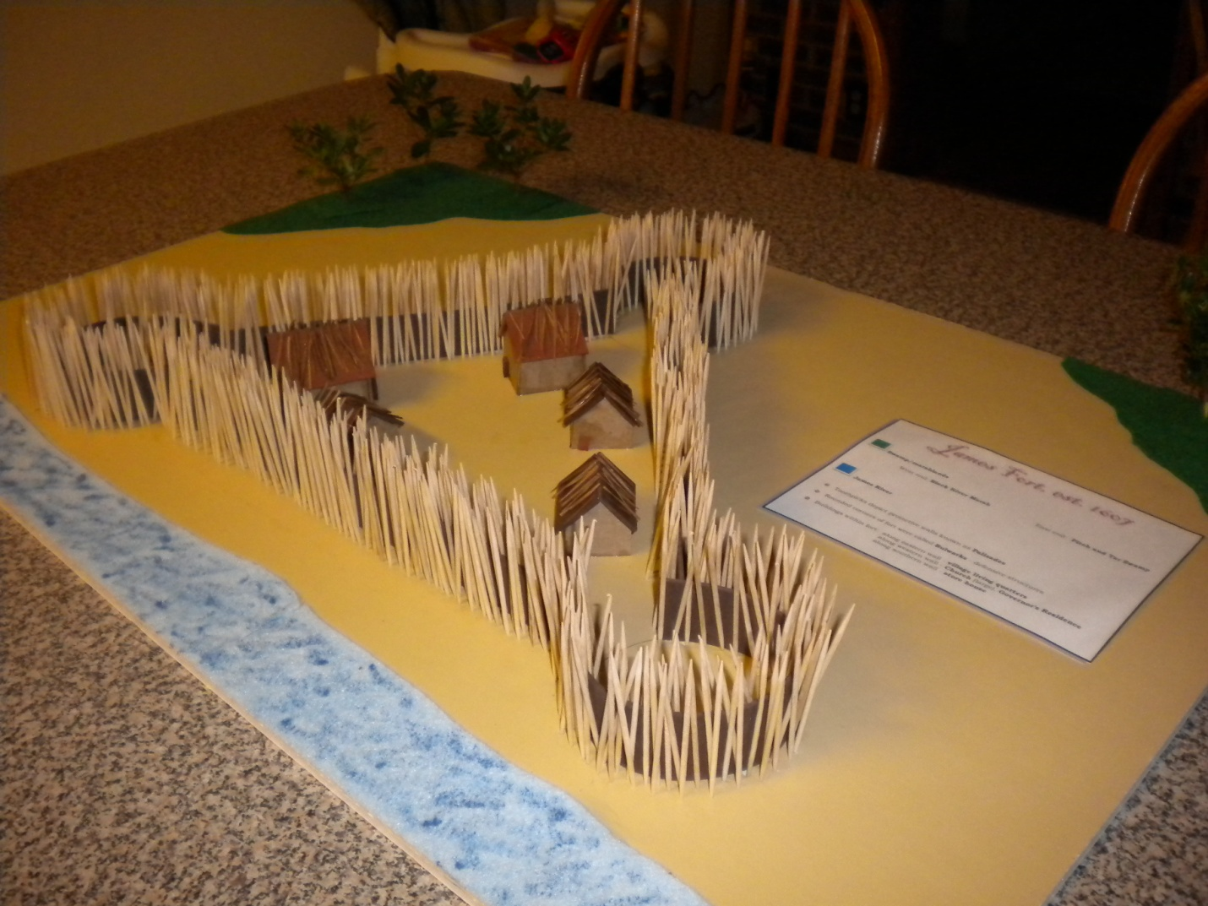

Assessment This project will be assessed based on following the criteria listed above and on the rubric.

Deadline
Students will be given one week of class project time to work on this project. If extra time is needed, the students will need to schedule time during homework club.(2:45-3:30)

